Homeward Trails Puppy Party Protocol

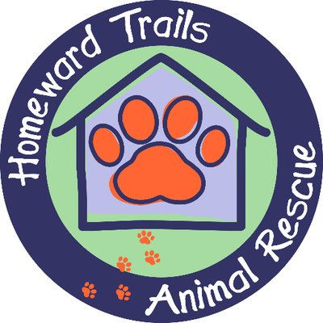

Thank you for booking a puppy party with Homeward Trails. Your party will not only bring happiness to your guests but your donation will allow us to save and assist sick and injured puppies who need us.

Please note that while our puppy parties are primarily meant to bring happiness and entertainment to you and your guests we do take the health welfare of our puppies very seriously. And so we have a few protocols that we ask you to follow. Your cooperation will play a vital role in our work socializing the puppies in a positive way and readying them for the big world.

Puppies are young creatures and can become scared and overwhelmed and as well as injured easily. These protocols are to ensure that everyone has a great time and remains safe and injury-free!

- Please do not feed the puppies food or treats of any kind. It can cause diarrhea which is disruptive to the pups and difficult for the fosters.

- Please note that we permit outdoor parties only when the temperature is between 65 and 75 degrees. If the temperature is lower than 65 or higher than 75, an indoor location must be secured.

- Please allow the pup to roam freely for as much of the time as possible either in their pen or out and about provided the area is fully secure. We encourage guests to pet the pups, cuddle them and play with them. But if a puppy is wiggly and wanting not to be held, we ask that guests respect that.

- When holding a puppy we ask that guests be seated. It is common for puppies to wiggle out of arms and a fall to the ground from even a foot up can be damaging. So please have guests seated when holding a puppy.

- If this is a children’s event, we will require an adult host to work with our volunteer to ensure these rules are being closely followed. We understand the excitement of the children and want them to have a positive experience. But fast moving children can easily step on and injure a puppy; a puppy can be easily dropped; and a puppy can become fearful if a child chases a puppy and/or does not allow the puppy to communicate if holding or roaming is what he/she wishes to do.

We very much look forward to your puppy party. Feel free to contact us with any additional questions regarding these protocols. Thank you again!

